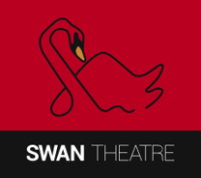 | LTG Southern Region One Day Conference  Saturday 21 November 2026  BOOKING FORM | 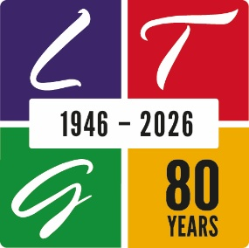

138 Park Street, Yeovil, Somerset, BA20 1QT
Booking Form: Please send one form per person to Sarah Ambrose at sarah.valentine1@yahoo.com by Friday 23 October.

The conference price is £24, which includes workshops, refreshments in the morning and afternoon, and a buffet lunch.
Delegates have the option of booking a ticket at a special delegate rate of £11.50 (normal price £13.50) for either Friday or Saturday evening to see our performance of Much Ado About Nothing by William Shakespeare. You are invited to book this directly on www.swan-theatre.co.uk so you can choose your own seats using concession code LTGSouth.
Please complete in BLOCK CAPITALS
Delegate name
Theatre
Role in theatre
Home address
Postcode
Mobile phone
Email address
Special dietary needs or allergies (e.g. Vegetarian (V), Gluten Free (GF), or Vegan (VE))

Accessibility needs? (e.g. parking space)

Please make a BACS payment of £24 with reference LTG and delegate surname to:
Account Name: The Swan Theatre
Sort Code: 30 99 98
Account: 02545931
Payment has been made by BACS of £24 for the day conference: | Yes / No
Questions for the Open Forum: please put your question(s) below:

