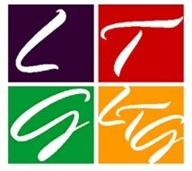 | The Lace Market Theatre  LTG Central Region CONFERENCE  Booking Form  Saturday 1st November 2025 | 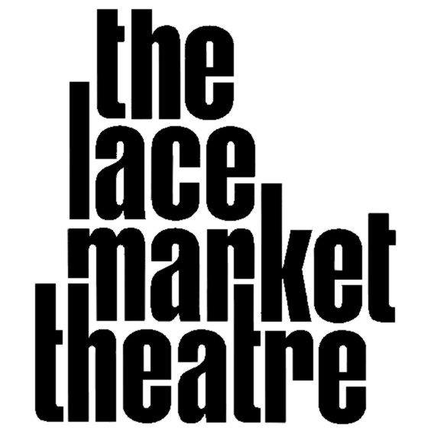
Please send one form per person attending to Lesley Brown, lesley.b130@gmail.com to arrive no later than 12 October 2025
Please complete in Block Capitals – payment details over.
Delegate Name
Position in Theatre
Theatre
Home Address:
Postcode:
Mobile telephone:
Home telephone:
email address:

Dietary needs (eg: Vegetarian (V), Gluten free (GF) or, Vegan (VE) )
Access or assistance needs (e.g. wheelchair); there are stairs to the toilets and meeting room

Item | Cost | Please tick | £
Delegate’s Fee - includes administration, refreshments, buffet lunch and ticket for the matinee or evening performance of Home, I’m Darling | £20 | ✔️ | £20
Saturday Buffet Lunch | Incl |  | X
Home, I’m Darling, Friday evening performance 19:30 | Incl |  | X
Home, I’m Darling, Saturday matinee performance 14:30 | Incl |  | X
Home, I’m Darling, Saturday evening performance 19:30 | Incl |  | X
Walking tour of the Lace Market area (after lunch) | Free |  | X
Nottingham Playhouse Backstage tour, 14:00 - 15:00 | £6
Your delegate total |  |  | £

Your payment should be made by BACS to Lace Market Theatre Trust Limited
Bank: Barclays
Sort Code: 20-63-25
Account No: 70565768
Ref: LTG (Theatre & Delegate’s surname)

Questions for the Open Forum please put your question(s) below:

